Docker Task -3
Task Description:

Create a custom docker image for nginx and deploy it using docker compose, where the volume bind mount should be at /var/opt/nginx location. Push the created custom docker image to your docker-hub.

Created the docker image for nginx and deployed using the docker compose.
docker-compose.yml
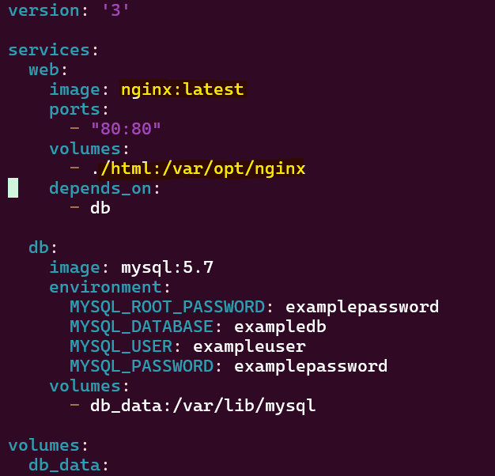

Docker image created.
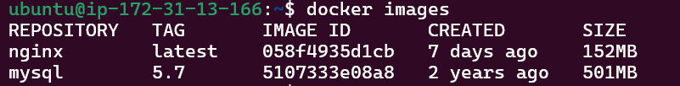

Logged in to docker hub.

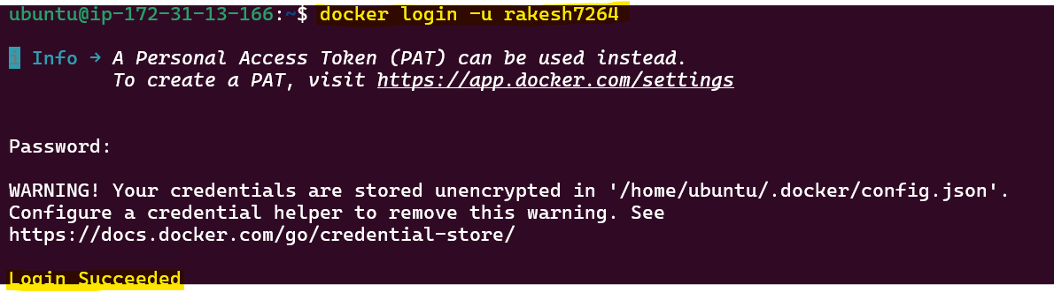
Pushed the created images to docker hub
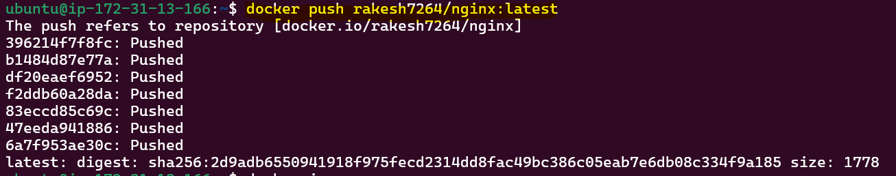

Images pushed to docker hub.
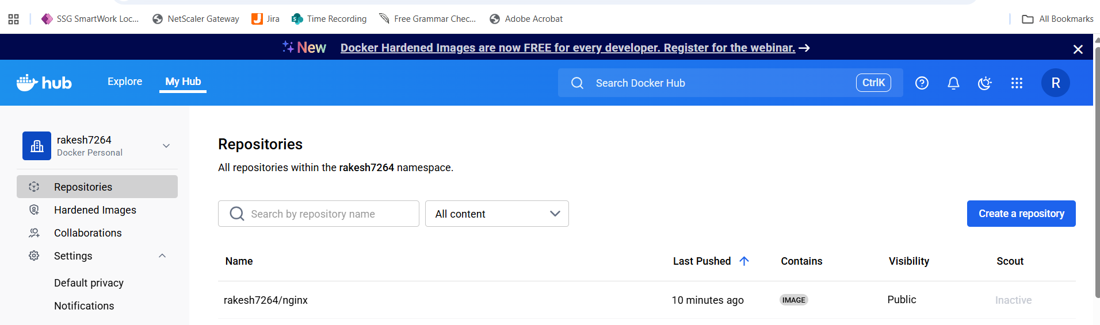
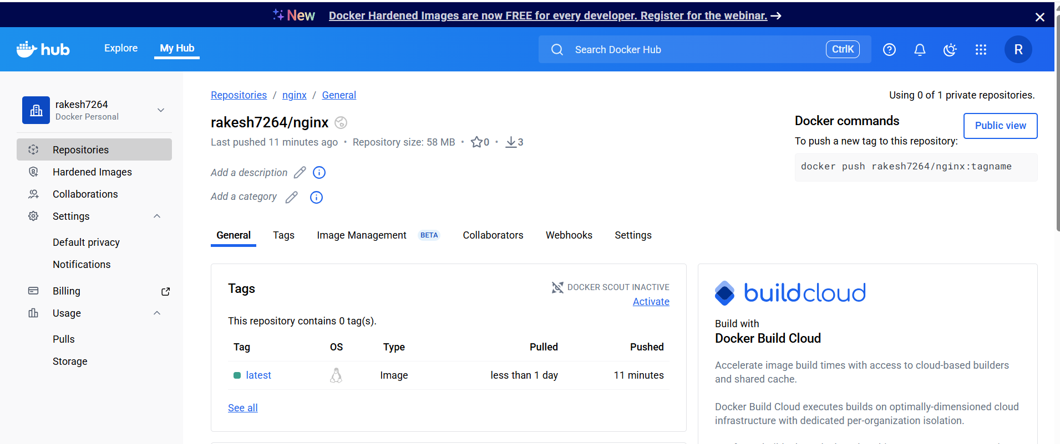

Created mysql repo in the docker hub

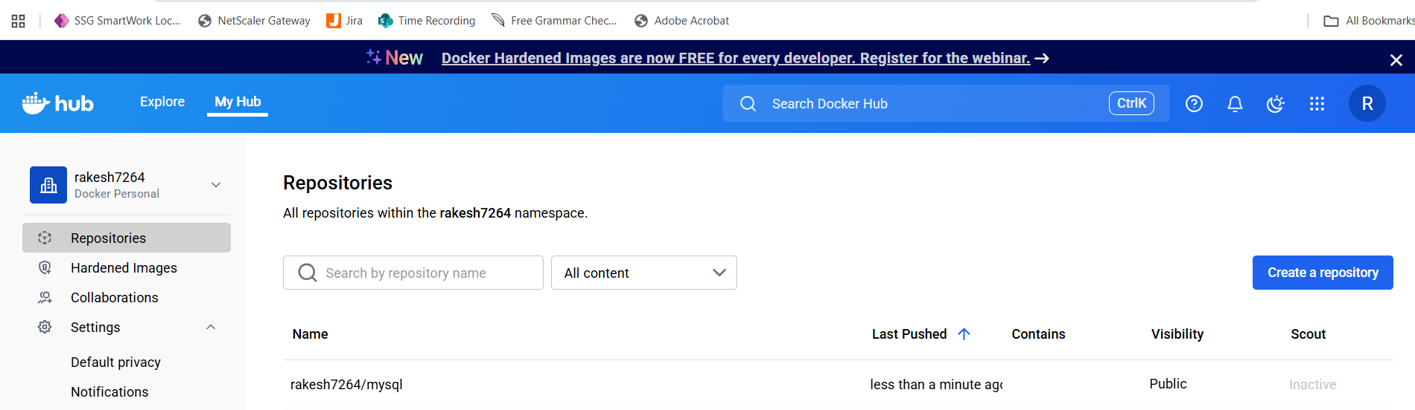

Created the tag.
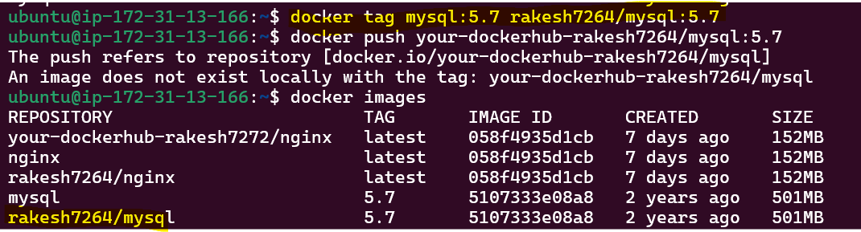

Pushed the mysql image to the docker hub.
